Supporting Information
Challenge and solution of characterizing glass transition temperature for conjugated polymers by differential scanning calorimetry
Authors: Zhiyuan Qian¹, Luke Galuska¹, William W. McNutt², Michael U. Ocheje³, Youjun He⁴, Zhiqiang Cao¹, Song Zhang¹, Jie Xu⁵, Kunlun Hong^{4,6}, Renée B. Goodman³, Simon Rondeau-Gagné ³, Jianguo Mei², Xiaodan Gu^{1*}
*Corresponding author Email: xiaodan.gu@usm.edu

1. School of Polymer Science and Engineering, Center for Optoelectronic Materials and Devices, The University of Southern Mississippi, Hattiesburg, MS, 39406, USA
2. Department of Chemistry, Purdue University, West Lafayette, Indiana 47907, USA
3. Department of Chemistry and Biochemistry, University of Windsor, Windsor, Ontario, N9B3P4, Canada
4. Center for Nanophase Materials Sciences, Oak Ridge National Laboratory, Oak Ridge, Tennessee 37831, USA
5. Naonotechnology and Science Division, Argonne National Laboratory, Lemont, IL 60439, USA
6. Department of Chemical and Biomolecular Engineering, University of Tennessee, Knoxville, TN, 37996
Correspondence to: Xiaodan Gu (E-mail: xiaodan.gu@usm.edu)

Table of contents
Figure S1. Specific heat capacity of sapphire.
Figure S2. Temperature profile for aging experiments.
Figure S3. DSC heating scans of PS, P3HT, P3(4MP)T, PNDI-C0, PNDI-C6, and PDPP-T3.
Figure S4. (a). DSC heating scans of PDPP-T3 under unaged and aged conditions (b). Baseline subtracted apparent heat capacity of PDPP-T3.
Figure S5. (a). DSC heating scans of PNDI-C6 under unaged and aged conditions (b). DSC heating scans of PNDI-C6 after cooling at different rates.
Figure S6. Small angle solution X-ray scattering data of (a) PNDI-C0 and (b) PNDI-C6.
Table S1.The fitting parameters for solution small angle solution X-ray scattering
Figure S7. (a). DSC cooling scans of P3(2EB)T at different cooling rates. (b). The correspond DSC reheating scans after cooling at different rates.
Figure S8. Temperature profile of isothermal crystallization measurement of P3(2EB)T.
Figure S9. Data process of melting peak integration
Figure S10. T_{g} as a function of relative degree of crystallinity
Estimate Δc_{p} of fully amorphous P3(2EB)T measured with Flash DSC
Figure S11. (a). Specific heat capacity of P3(2EB)T in melt state with conventional DSC (b) Symmetric analysis.
Figure S12. Cooling scans of PDPP-T3 and PNDI-C0 at different cooling rates.
Figure S13. Schematic of temperature dependence of enthalpy for a typical amorphous polymer.
Figure S14. Physical aging of PS.
Figure S15. (a). Thermal property of PNDI-C0 measured with modified DMA and (b). DSC heating scans of PNDI-C0 under unaged and aged conditions.
Synthesis of PNDI-C) and PNDI-C6.

Figure S1. Specific heat capacity of sapphire as a function of temperature. Data calculated based on the equations in the work by Ditmars, et al.¹

Figure S2. (a) Schematic temperature profile for a physical aging experiment. T_{h} and T_{l} are the high and low temperature limits in the experiment. T_{m}, T_{g} and T_{a} are melting temperature, glass transition temperature and aging temperature, respectively. t_{a} is the aging time. (b), (c) and (d) are temperature profiles of aging experiment for PDPP-T3, PNDI-C6 and PNDI-C0, respectively. For PDPP-T3, cooling rate of 10 K/min, and heating rate of 30 K/min was used. For PNDI-C6 and PNDI-C0, cooling rate and heating rate were 30 K/min.
Figure S3. DSC heating scans (endo down) of (a). PS, (b). P3HT, (c). P3(4MP)T, (d). PNDI-C0, (e). PNDI-C6, and (f). PDPP-T3 with heating rate of 10 K/min. A melting peak in high temperature end can be seen for P3HT (225.5 °C), P3(4MP)T (254.5 °C), PNDI-C0 (319.5 °C), PNDI-C6 (64.3 °C) and PDPP-T3 (291.7 °C), respectively.

Figure S4. (a). DSC heating scans of PDPP-T3 under unaged and aged conditions (aged at 0, -5 and -10 °C for 60 min, respectively). Enthalpy overshoot relates to structure recovery, which is a signature of glass transition is observed for aged sample scans. (b). Baseline subtracted apparent heat capacity of PDPP-T3, the dotted line and dashed line are glass line and liquid line, respectively.

Figure S5. (a). DSC heating scans (endo down) of PNDI-C6 under unaged and aged conditions (aged at 0, -5 and -10 °C for 60 min, respectively). (b). DSC heating scans (endo down) of PNDI-C6 after cooling at different rates, as indicated in the legend. In both figures, enthalpy overshoot relates to structure recovery, which is a signature of glass transition, is observed.

Figure S6. Small angle solution X-ray scattering data of (a) PNDI-C0 and (b) PNDI-C6.

Table S1.The fitting parameters for solution small angle solution X-ray scattering
Material | Persistence length (Å) | Uncertainty (Å)
PNDI-C0 | 54 | 22
PNDI-C6 | 32 | 17

Figure S7. (a). DSC cooling scans (exo up) of P3(2EB)T at different cooling rates. (b). The correspond DSC reheating scans (endo down) after cooling at different rates. Cooling rates are indicated in both legends. The heating rate is 10 K/min. For cooling rates faster than 30 K/min, a cold crystallization exothermic peak, due to incomplete crystallization on cooling, is observed in the reheating scan at approximately 75 °C.

Figure S8. The schematic temperature profile of isothermal crystallization of P3(2EB)T performed at 90 °C with flash DSC. Adapted with permission. Copyright 2018, American Chemistry Society.²

Figure S9. Data process on integration of melting peak. The black line is the raw data. The red line is smoothed data using the smooth function in STARe Evaluation software with the following settings: first order and 75 points. The blue line is the baseline. Area were obtained by integration between the red line and blue line.

Figure S10. T_{g} as a function of RDOC for P3(2EB)T after isothermal crystallized at 90 °C for a certain time frame (0 s to 20,000 s) measured with flash DSC.

Estimate Δc_{p} of fully amorphous P3(2EB)T measured with Flash DSC
One challenge of estimating Δc_{p} of fully amorphous P3(2EB)T measured with Flash DSC is obtaining the sample mass m, which is normally in the nanogram scale. In this case, the symmetric analysis³⁻⁷ can be utilized in the temperature range at which no phase transitions (225 °C to 240 °C, which is above the T_{m} of P3(2EB)T) take place when same heating and cooling rate are used:
$$∆\dot{Q}\left(T\right)={\dot{Q}}_{H}\left(T\right)-{\dot{Q}}_{C}\left(T\right)=2∙c_{p}\left(T\right)∙m∙β$$
where $\dot{Q}$ is heat flow, subscripts H and C stand for heating and cooling, respectively, $m$ is the sample mass, $β$ is the heating/cooling rate, $c_{p}\left(T\right)$ is the specific heat capacity of P3(2EB)T in its melt state (225 °C to 240 °C) obtained using conventional DSC with Sapphire method. Then, $m$ was estimated to be 67 ng.

Figure S11. (a). Specific heat capacity of P3(2EB)T in its melt state obtained using conventional DSC with Sapphire method. (b). Heat flow of P3(2EB)T in its melt state obtained with Flash DSC at a heating/cooling rate of 1000 K/s.

Figure S12. Cooling scans of (a) PDPP-T3 and (b) PNDI-C0 measured with Mettler-Toledo Flash DSC 2+ and UFH 1 sensor at different cooling rates, as indicated in the legend. The curves suggest that the crystallization on cooling cannot avoid even with rate up to 10,000 K/s.

Figure S13. Schematic of temperature dependence of enthalpy for a typical amorphous polymer.

Figure S14. (a) The heating scans of a PS aged at 85 °C for various aging times (t_{a}) measured by conventional DSC. Adapted with permission.⁸ Copyright 2013, American Chemistry Society. (b) The heating scans of a 160 nm PS film measured by flash DSC at a heating rate (β) of 600 K/s after cooling at various cooling rate (q). Adapted with permission. Copyright 2013, American Chemistry Society.⁹
Figure S15. (a). The storage modulus, loss modulus and tanδ of PNDI-C0 measured with modified DMA technique, where the PNDI-C0 solution was drop casted on a woven glass fiber and then measured with DMA. Two major peaks are observed in tanδ curve, one located at -15 °C is sidechain T_{g}, the other one at 137 °C is attributed to the backbone T_{g}. The responses are consistent with literature report for same material by different groups.^{10,11} (b). DSC scans of PNDI-C0 under unaged and aged (aged at 70 °C for 180 min) conditions. Enthalpy relaxation is observed in the aged scan.

Synthesis of PNDI-C0 and PNDI-C6
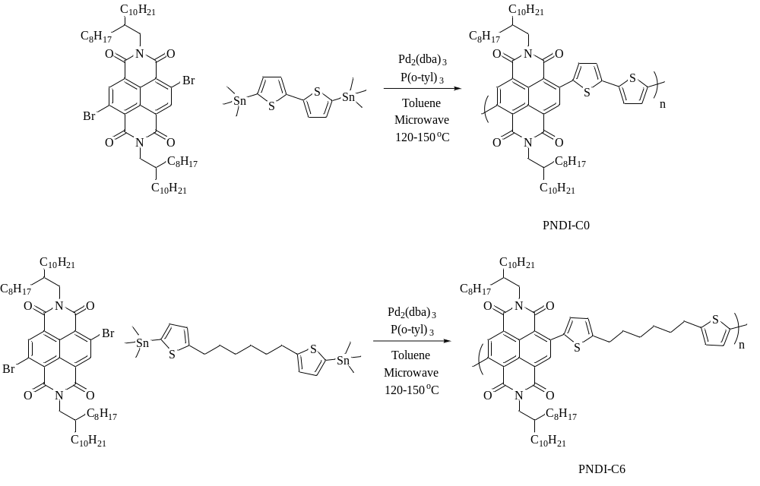
Scheme 1 – Route for NDI Polymers
General Method of Polymerization.
4,9-dibromo-2,7-bis(2-octyldodecyl)benzo[lmn][3,8]phenanthroline-1,3,6,8(2H,7H)-tetraone (0.17 mmol) and ditin monomer (0.17 mmol,1 equiv) were added into a 35 mL microwave vessel. Upon stirring, the monomers were dissolved in 10 mL of anhydrous toluene and degassed with nitrogen for 15 min. Pd₂(dba)₃ (4 mol %) and tris(o-tolyl) phosphine (8 mol %) were added under nitrogen. The vessel was capped with a snap cap and transferred to the CEM Discover automatic microwave reactor. The reaction conditions were listed as follows: power cycling mode; power, 200 W; power cycles, 100; temperature, 150−180 °C; heating, 120 s; cooling, 30 s; pressure, 150 psi; stirring, high. After the polymerization was complete, the mixture was taken up and precipitated into methanol. The solids were collected by a high quality glass thimble, which was purified by Soxhlet extraction with acetone, hexane, and chloroform. The chloroform fraction was precipitated into methanol. The collected polymer was dried at 60 °C under vacuum with the yields of 90% for PNDI-C0 and 93% for PNDI-C6. Molecular weights and polydisperities were determined by room temperature gel permeation chromatography (GPC) performed in tetrahydrofuran under room temperature with a Polymer Laboratories PL-GPC20. The molecular weights were calculated using a calibration curve based on polystyrene standards.

References
1.Ditmars, D.; Ishihara, S.; Chang, S.; Bernstein, G.; West, E. J. Res. Natl. Bur. Stand. 1982, 87, 159.
2.Luo, S.; Kui, X.; Xing, E.; Wang, X.; Xue, G.; Schick, C.; Hu, W.; Zhuravlev, E.; Zhou, D. Macromolecules 2018, 51, 5209.
3.Cebe, P.; Partlow, B. P.; Kaplan, D. L.; Wurm, A.; Zhuravlev, E.; Schick, C. Thermochim. Acta 2015, 615, 8.
4.Balko, J.; Rinscheid, A.; Wurm, A.; Schick, C.; Lohwasser, R. H.; Thelakkat, M.; Thurn-Albrecht, T. J. Polym. Sci., Part B: Polym. Phys. 2016, 54, 1791.
5.Abdelaziz, A.; Zaitsau, D. H.; Mukhametzyanov, T. A.; Solomonov, B. N.; Cebe, P.; Verevkin, S. P.; Schick, C. Thermochim. Acta 2017, 657, 47.
6.Yagofarov, M. I.; Lapuk, S. E.; Mukhametzyanov, T. A.; Ziganshin, M. A.; Schick, C.; Solomonov, B. N. Thermochim. Acta 2018, 668, 96.
7.Pallaka, M. R.; Unruh, D. K.; Simon, S. L. Thermochim. Acta 2018, 663, 157.
8.Koh, Y. P.; Simon, S. L. Macromolecules 2013, 46, 5815.
9.Gao, S.; Koh, Y. P.; Simon, S. L. Macromolecules 2013, 46, 562.
10.Sharma, A.; Pan, X.; Bjuggren, J. M.; Gedefaw, D.; Xu, X.; Kroon, R.; Wang, E.; Campbell, J. A.; Lewis, D. A.; Andersson, M. R. Chem. Mater. 2019, 31, 6740.
11.Balar, N.; Rech, J. J.; Henry, R.; Ye, L.; Ade, H.; You, W.; O’Connor, B. T. Chem. Mater. 2019, 31, 5124.

