Supporting Information

High Coloration Efficiency Black-to-Transmissive Polyazoisoindigo-Based Dual Polymer Electrochromics

Zhiyang Wang, John M. Andjaba, Christopher Rybak, Liyan You, Christopher Uyeda*, Jianguo Mei*

Department of Chemistry, Purdue University, West Lafayette, Indiana, 47907, United States

Email: jgmei@purdue.edu

Synthesis of ECP-R

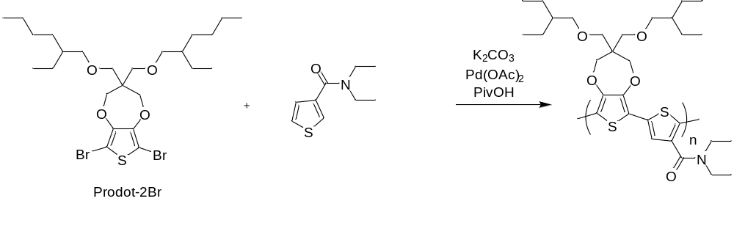

The monomer N,N-diethylthiophene-3-carboxamide is made according to reported method.¹ Charge 1.0g ProDot-2Br, 0.306g N,N-diethylthiophene-3-carboxamide, 0.05g PivOH, 0.6g K2CO3, 0.008g Pd(OAc)2 into a 100mL reactor with stir bar under slight nitrogen flow. Vacuum and refilled with nitrogen for three times. 7mL degassed DMAc is added into the reactor with syringe. The mixture is heating to 120oC for overnight. The mixture is poured into 100mL Methanol/1N HCl (1/1) solution. Filter to get the solid and dissolved into 20mL CHCl3, washed with 1N HCl and water. Precipitate with methanol to get the polymer solid. (Y=85%).1H NMR (400 MHz, CDCl3), δ (ppm): 7.11 (m, 1H), 4.17-4.14 (m, 4H), 3.58 (br, 6H), 3.31 (br, 6H), 1.50-0.87 (m, 36H). (Mn=7.1kDa, PDI=1.6)

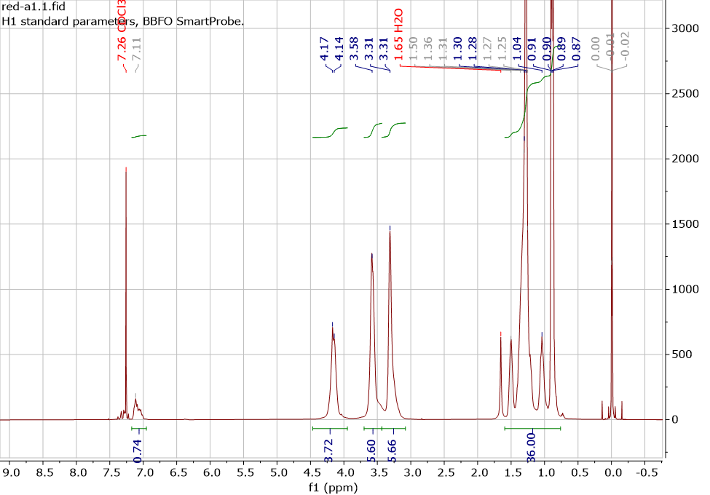
Figure S1. ¹H NMR spectrum of ECP-R.
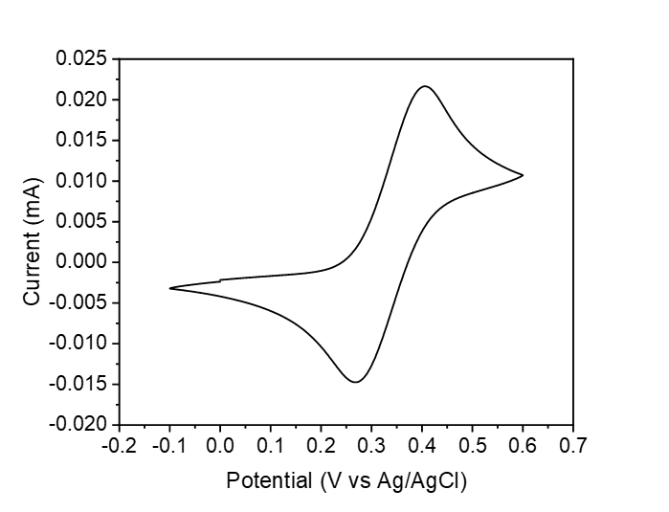
Figure S2. Calibration of the Ag/AgCl reference electrode to ferrocenium/ferrocene redox couple.

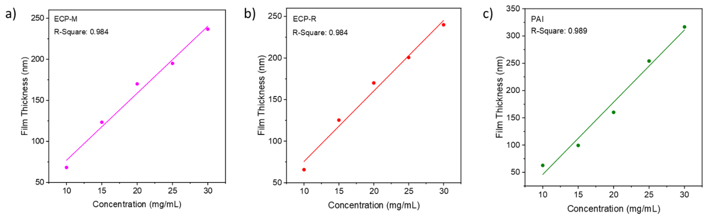
Figure S3. Thickness-concentration correlations of a) ECP-M, b) ECP-R, and c) PAI. The data are fitted to linear function with R-squares shown in the figure.

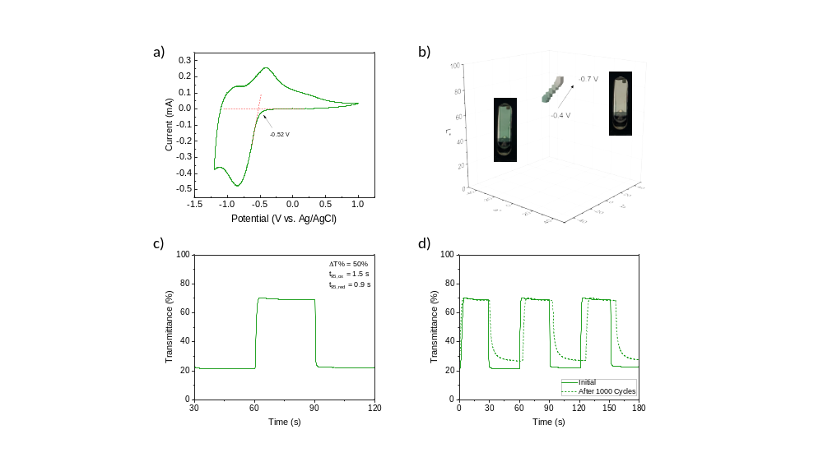
Figure S4. PAI. a) Cyclic voltammogram of the polymer film. b) CIE L*a*b* color coordinates as a function of the applied potential. c) Switching kinetics of the polymer. d) Switching kinetics of the polymer in its initial state (solid) and after 1000 CV cycles (dashed).

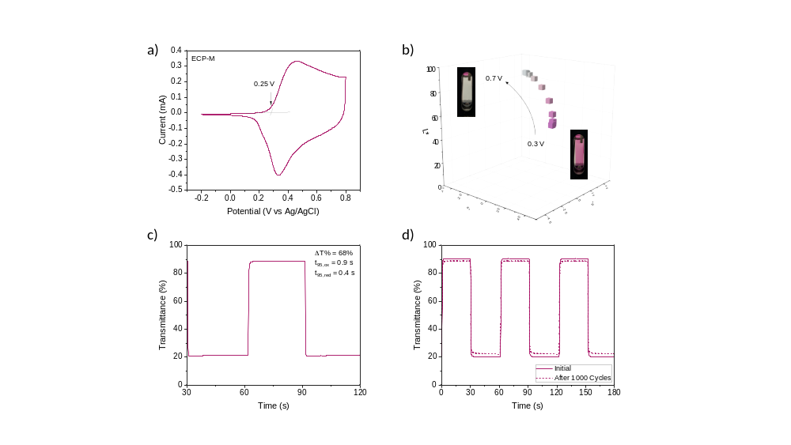
Figure S5. ECP-M. a) Cyclic voltammogram of the polymer film. b) CIE L*a*b* color coordinates as a function of the applied potential. c) Switching kinetics of the polymer. d) Switching kinetics of the polymer in its initial state (solid) and after 1000 CV cycles (dashed).
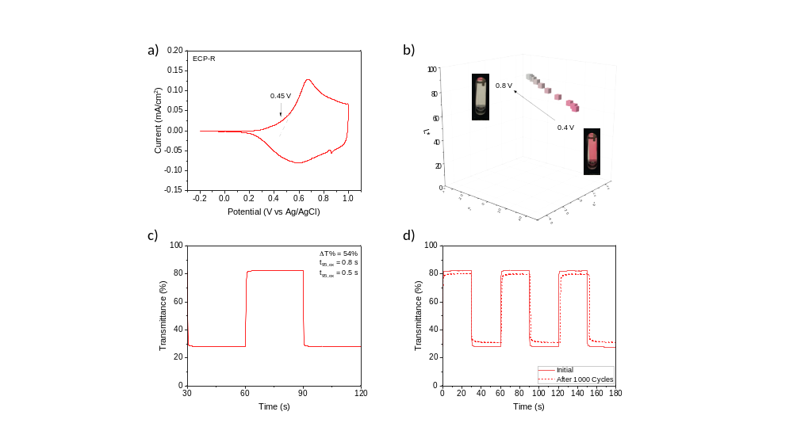
Figure S6. ECP-R. a) Cyclic voltammogram of the polymer film. b) CIE L*a*b* color coordinates as a function of the applied potential. c) Switching kinetics of the polymer. d) Switching kinetics of the polymer in its initial state (solid) and after 1000 CV cycles (dashed).

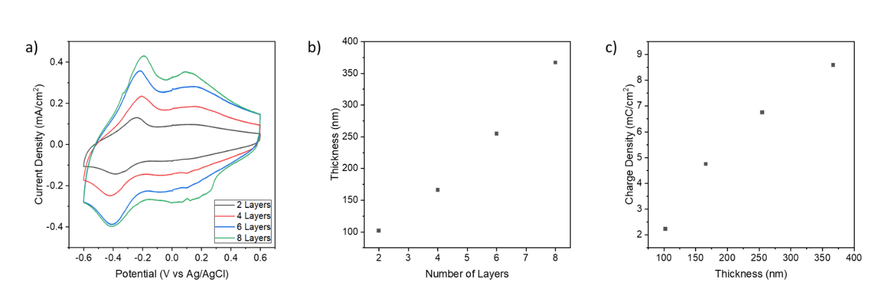
Figure S7. a) Cyclic voltammograms of multiple layers of VO_{x} ion storage material. b) The correlation between number of layers and thickness for VO_{x} ion storage material. c) The charge density of VO_{x} ion storage material at different thickness.
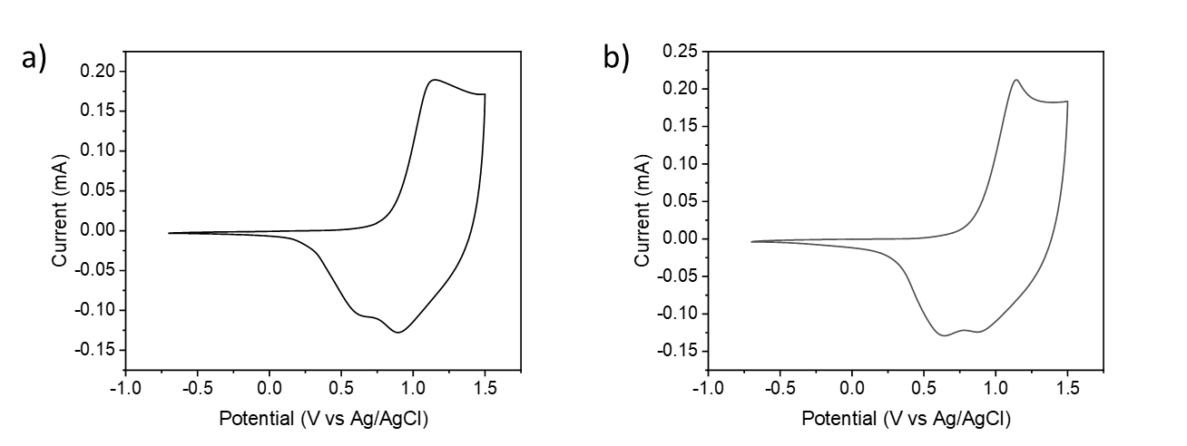
Figure S8. Cyclic voltammograms of a) ECP|PAI device and b) ECP|PAI in two electrode cell.

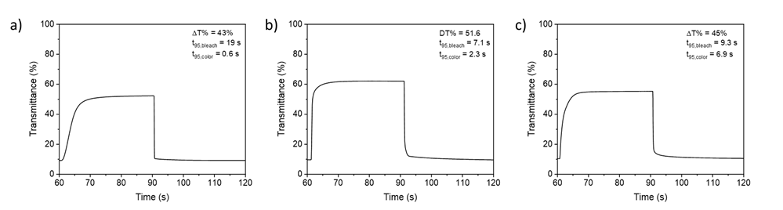
Figure S9. Switching kinetics of ECD consisted of a) ECP-M|PAI in charge-unbalanced configuration, b) ECP-M|PAI in charge-balanced configuration, and c) ECP-R|PAI. The switching kinetics were measured at 550 nm by varying the applied voltage between –0.3 and 1.5 V by SPFC.

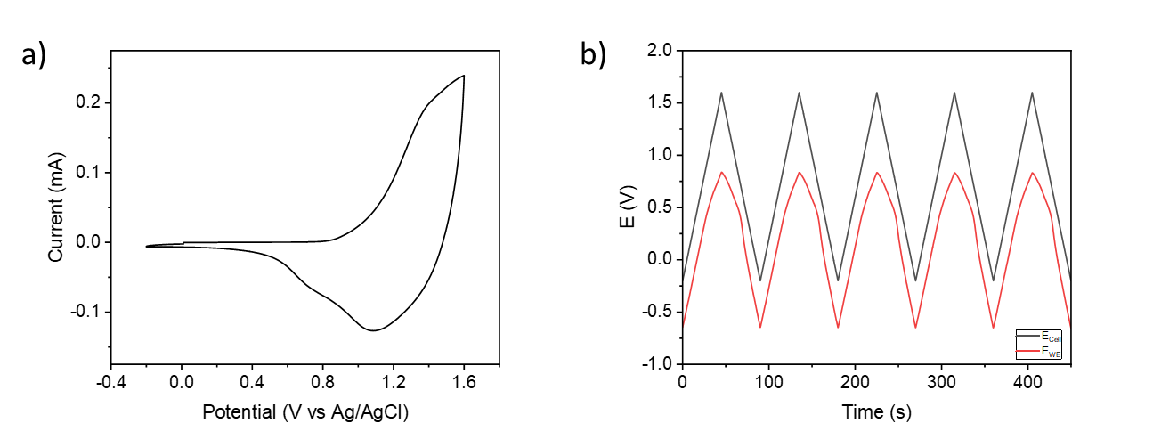Figure S10. a) Cyclic voltammogram of ECP-R|PAI device. b) CV experiment of the ECP-R|PAI two-electrode cell. The voltage of the whole cell (black) and the voltage distributed on working electrode (red) are shown.

Table S1. Optical contrast, CIE L*a*b* color coordinates, and switching times for the ECDs.
ECD | ∆%T (at 550 nm)ª | Colored state L*a*b* | Bleach state L*a*b* | T₉₅ colored to bleach (s)^{b} | T₉₅ bleach to colored (s)^{b}
ECP-M|PAI (unbalanced) | 43 | 42, 6, −8 | 73, −4, 4 | 19 | 0.6
ECP-M|PAI (balanced) | 52 | 40, 6, −6 | 83, −1, 4 | 7.1 | 2.3
ECP-R|PAI | 45 | 40, 7, 1 | 75, −1, 5 | 9.3 | 6.9
ª Difference between transmittance measured in the fully oxidized and fully neutral states.
^{b} The time required to reach 95% from colored to colorless, and colorless to colored state.

Reference

1. Zhao, Y.; Snieckus, V. C–H Activation by Amide Chelation Control: Ruthenium-Catalyzed Direct Synthesis of 2-Aryl-3-furanamides. Adv. Synth. Catal. 2014, 356, 1527 – 1532

