Supporting Information

High-Performance Low-Emissivity Paints Enabled by N-Doped Poly(benzodifurandione) (n-PBDF) for Energy-Efficient Buildings
Xiaojie Liu,† Won-June Lee,† Daniel William Carne, Yanpei Tian, Andrea Felicelli, Yue Lei, Joseph A. Romo, Liyan You, Zixin Xiong, Orlando Gabriel Rivera Gonzalez, Abdulrahman Aljwirah, Qiaoqiang Gan, Jianguo Mei,* and Xiulin Ruan*

Note S1. Materials and methods
Materials: All reagents for the synthesis, ink formulation, and characterization were purchased from Sigma Aldrich, Fisher Scientific, and Acros Organics and used without further purification unless otherwise mentioned. Dimethyl sulfoxide (DMSO, anhydrous) and ethanol (anhydrous, 200 proof, 100% undenatured) were purchased from Sigma-Aldrich and Fisher Scientific and used without any further purification. Commercial onyx black paint was purchased from Tex-Cote LLC. Commercial green, blue, and yellow paints were resilient exterior acrylic latex paints, which were purchased from Sherwin-Williams. The Ford red paint was purchased from Rust-Oleum (‎Farm & Implement Enamel Paint). The n-type doped PBDF was synthesized in DMSO, as described in a previous study^{[1]}. Cellulose membrane dialysis bag tubing (10K MWCO, SnakeSkinTM) and glass slides (Corning Inc. US) were purchased from Fisher Scientific with thermal conductivity of 0.8 W/m K and specific heat capacity of 840–880 J/kg K.
Low-e paint fabrication: Commercial paints of various colors were applied to glass substrates via custom home-built blade coating. These were then allowed to dry under ambient conditions for approximately 4 h to form color-painted films. To prepare the low-emissivity (low-e) n-PBDF ink solution, the synthesized n-PBDF solution, previously dialyzed to 10 kDa, was gradually added to stirred anhydrous ethanol at a 1:6 (v/v) ratio, ensuring a highly homogenous dispersion. The mixture was stirred at room temperature and 500 rpm for at least 2 h. This solution maintained its dispersion stability for more than two weeks. For the fabrication of uniform and precise low-e n-PBDF films, an automated ultrasonic spray coating system (ExactaCoat, Sono-Tek Corp., US) was used. The system provided uniform coatings exceeding 100 nm in thickness, utilizing a 120 kHz ultrasonic spray nozzle (Impact, Sono-Tek) with a liquid flow rate of 0.5 ml/min and nozzle-to-substrate distance of 50 mm, employing an arc-shaped pattern with repeated cycling. To ensure reliability and reproducibility, film thickness precision (standard deviation ±2%) was assessed using a surface profiler (DektakXT, Bruker). The measurements were conducted at a minimum of five points across different batches of glass substrates under identical coating conditions.
Characterizations: The surface roughness and the presence of nanoscale particulate features on the surface of the film were characterized using atomic force microscopy (AFM) (Dimension Icon, Bruker Inc.) in the ambient air at room temperature, employing tapping mode at a scan rate of 0.2 Hz over a measurement area of 2 µm × 2 µm. Statistical analysis of the diameter distribution of particulate features, identified from the AFM phase images, was conducted using the NanoScope Analysis software (v.3.0) with its particle analysis function (n > 220). Additionally, the statistical distribution of the diameter of the disjoint features was quantified using SEM images analyzed using ImageJ software (v.1.54) (n > 250). The hydrodynamic radius of the n-PBDF features, solvated and dispersed within the n-PBDF ink solution, was characterized by Dynamic Light Scattering (DLS) (DynaPro Nanostar 2, Wyatt Technology Corporation, US) without prior syringe filtration, using a homogeneous solution diluted to 0.015 mg/ml. All measurements were averaged from the data obtained from five replicates.
Optical characterizations: For the optical characterization of the n-PBDF ink solution prepared through a series dilution method at various concentrations (10-, 20-, 50-, and 100-fold), 3 ml of each solution was used in a cleaned quartz liquid cell (light path length: 1 cm). UV-VIS-NIR absorption spectra were recorded using an Agilent Cary 5000 UV-VIS Spectrometer (1 nm resolution). Absorbance FT-IR spectra were measured using a Nicolet 6700 FT-IR spectrometer (Thermo Nicolet Corp.) equipped with an Attenuated Total Reflectance (ATR) Smart iTR accessory, utilizing a single-bounce diamond crystal, across a wavenumber range of 4000 to 800 cm⁻¹, with a spectral resolution of 4 cm⁻¹ and an averaging of 64 scans. Baseline correction and maximum peak normalization were performed without additional smoothing using the OMNIC software (v.8.3, Thermo Nicolet Corp.).
The total hemispheric transmittance and reflectance from 300 to 2500 nm were measured by an ultraviolet-visible-near-infrared (UV-Vis-NIR) spectrometer with an integrating sphere and a certified Spectralon diffuse reflectance standard (Lambda 950, Perkin Elmer, Inc., USA). A Nicolet iS50 FTIR spectrometer with a PIKE Technologies integrating sphere was used to measure the total hemispheric transmittance and reflectance between 2.5 and 20 μm. Kirchhoff’s law and the thermal equilibrium principle were used to derive the emittance ($ɛ$) spectrum based on the measured reflectance ($r$) and transmittance ($t$) spectra, which is $ɛ=1-r-t$.

Note S2. Calculation of overall solar reflectance and infrared thermal emittance
The overall hemispherical solar reflectance, $\overline{R}$, is the function of wavelengths and incident angles, which is defined as^{[2]}:
$$\overline{R}\left(λ,θ,Φ\right)=\frac{\int_{0.3µm}^{2.5µm}{I_{sun}\left(λ,θ,Φ\right)R\left(λ,θ,Φ\right)dλ}}{\int_{0.3µm}^{2.5µm}{I_{solar}\left(λ,θ,Φ\right)dλ}}$$
Where $λ$ is the wavelength of the solar radiation, $θ$ is the zenith angle, and $Φ$ is the azimuth angle. $I_{sun}$ is the incident solar intensity at AM 1.5 which is confined from 0.3-4.0 μm. Here, the integration interval is limited from 0.3 to 2.5 μm, covering over 99% power intensity of the solar intensity. $R\left(λ,θ,Φ\right)$ is the spectral directional reflectance.
The overall infrared thermal emittance, $\overline{ɛ}$, is also dependent on the wavelengths and incident angles, which is expressed as^{[2]}:
$$\overline{ɛ}\left(λ,θ,Φ\right)=\frac{\int_{2.5µm}^{20µm}{I_{bb}\left(λ,θ,Φ\right)\left[1-R\left(λ,θ,Φ\right)\right]dλ}}{\int_{2.5µm}^{20µm}{I_{bb}\left(λ,θ,Φ\right)dλ}}$$
Where $I_{bb}\left(λ,θ,Φ\right)$ is the blackbody radiation intensity given by Planck’s law. It should be noted that all the spectra used in this work were measured at room temperature.

Note S3. Theoretical thermal performance for the studied building
A thermal model was developed to characterize the surface temperature of the studied building surface when it faced a neighboring object and an underlying ground. The thermal equilibrium equation for the studied building walls is expressed below^{[3]}:
$$P_{rad}\left(T_{wall}\right)-P_{sun}-P_{a}\left(T_{a}\right)-P_{n}\left(T_{n}\right)-P_{g}\left(T_{g}\right)+P_{conv}\left(T_{wall},T_{a}\right)=0$$
Where $P_{rad}\left(T_{wall}\right)$ stands for the radiative cooling power of the studied building wall with the surface temperature of $T_{wall}$. $P_{sun}$ is the absorbed solar power intensity. $P_{a}\left(T_{a}\right)$ represents the absorbed thermal radiative power emitted from the ambient with the ambient temperature of $T_{a}$. $P_{n}\left(T_{n}\right)$ means the absorbed thermal radiative power from the neighboring object with the surface temperature of $T_{n}$. $P_{g}\left(T_{g}\right)$ is the absorbed thermal radiative power emitted from the ground with the surface temperature of $T_{g}$. $P_{conv}\left(T_{wall},T_{a}\right)$ is the convective power between the ambient and the studied building surface.
$$P_{rad}\left(T_{wall}\right)=\int_{0}^{π}{\int_{0}^{π}{\int_{0}^{∞}{I_{bb}\left(T_{wall},λ\right)ɛ^{'}\left(λ,θ\right)cos\left(θ\right)sin\left(θ\right)dλdθdΦ}}}$$
Where $I_{bb}\left(T_{wall},λ\right)={2hc^{2}λ^{-5}}/{\left[exp\left({hc}/{λk_{B}T_{wall}}\right)-1\right]}$ defines the spectral radiance of blackbody at a certain temperature. Here, $h$ is the Planck’s constant, $c$ is the light velocity, and $k_{B}$ is the Boltzmann constant. $ɛ^{'}\left(λ,θ\right)=\frac{1}{π}\int_{0}^{π}{ɛ\left(λ,θ,Φ\right)dΦ}$ is the averaged emissivity over the azimuth angle in the zenith direction for the building wall, and here, $ɛ\left(λ,θ,Φ\right)$ is the spectral emissivity of the studied building wall. The azimuth angle of a wall is defined in the range of 0 to π, excluding the angle of the back portion of the wall (π to 2π), which is not oriented towards the surrounding objects.
$$P_{a}\left(T_{a}\right)=P_{a_d}+P_{a_r}$$
$$=\int_{0}^{π}{\int_{0}^{θ_{1}}{\int_{0}^{∞}{I_{bb}\left(T_{a},λ\right)ɛ^{'}\left(λ,θ\right)ɛ_{a}\left(λ,θ\right)cos\left(θ\right)sin\left(θ\right)dλdθdΦ}}}$$
$$+{ R}_{g}\int_{0}^{π}{\int_{θ_{3}}^{π}{\int_{0}^{∞}{I_{bb}\left(T_{a},λ\right)ɛ^{'}\left(λ,θ\right)ɛ_{a}\left(λ,θ\right)cos\left(θ\right)sin\left(θ\right)dλdθdΦ}}}$$
Where $P_{a_d}$ is the thermal radiative power absorbed from the ambient and directly emitted to the studied building wall, and $P_{a_r}$ is the thermal radiative power absorbed from the ambient and reflected from the ground to the studied building wall. $R_{g}$ is the spectral reflectivity of the ground. $ɛ_{a}\left(λ,θ\right)$ is the emissivity of atmosphere, which can be given by $ɛ_{a}\left(λ,θ\right)=1-{t\left(λ\right)}^{1/{cos\left(θ\right)}}$, where $t$ is the atmospheric transmission.
$$P_{n}\left(T_{n}\right)=P_{n_d}+P_{n_r}$$
$$=\int_{0}^{π}{\int_{θ_{1}}^{θ_{2}}{\int_{0}^{∞}{I_{bb}\left(T_{n},λ\right)ɛ^{'}\left(λ,θ\right)ɛ_{n}\left(λ,θ\right)cos\left(θ\right)sin\left(θ\right)dλdθdΦ}}}$$
$$+{ R}_{g}\int_{0}^{π}{\int_{θ_{2}}^{θ_{3}}{\int_{0}^{∞}{I_{bb}\left(T_{n},λ\right)ɛ^{'}\left(λ,θ\right)ɛ_{n}\left(λ,θ\right)cos\left(θ\right)sin\left(θ\right)dλdθdΦ}}}$$
Where $P_{n_d}$ is the thermal radiative power absorbed from the neighboring object and directly emitted to the studied building wall, and $P_{n_r}$ is the thermal radiative power absorbed from the neighboring object and reflected from the ground to the studied building wall. $ɛ_{n}\left(λ,θ\right)=ɛ_{n,0} cos\left(\frac{π}{2}-θ\right)$is the emissivity of neighboring object, and $ɛ_{n,0}$ is the assumed building surface emissivity.
$$P_{g}\left(T_{g}\right)=\int_{0}^{π}{\int_{θ_{2}}^{π}{\int_{0}^{∞}{I_{bb}\left(T_{g},λ\right)ɛ^{'}\left(λ,θ\right)ɛ_{g}\left(λ,θ\right)cos\left(θ\right)sin\left(θ\right)dλdθdΦ}}}$$
Where $ɛ_{g}\left(λ,θ\right)=\left(1-{ R}_{g}\right)cos\left(π-θ\right)$ is the emissivity of ground. As illustrated in Figure S8, $θ_{1}$, $θ_{2}$, and $θ_{3}$ are the boundary angles of the four different situations for the heat absorption to the studied building wall, and they can be calculated as: $θ_{1}=\tan^{-1}\left[D/{\left(H_{n}-H_{wall}\right)}\right]$, $θ_{2}=π-\tan^{-1}\left(D/{H_{wall}}\right)$, and $θ_{3}=π-\tan^{-1}\left[D/{\left(H_{wall}+H_{n}\right)}\right]$, respectively, where, $D$ is the distance between the studied building wall and the neighboring object, $H_{n}$ is the height of the neighboring object, and $H_{wall}$ is the height of the calculated point on the studied building wall.
$$P_{conv}\left(T_{wall},T_{a}\right)=h_{c}\left(T_{wall}-T_{a}\right)$$
Where $h_{c}$ is the convective heat exchange coefficient.

Note S4. Outdoor field test
The outdoor field tests for examining the thermal regulation performance of our low-e paint were conducted on the rooftop of a three-story building at Purdue University, West Lafayette, IN, USA. In the field test, two structurally identical house models were constructed using the same 2 mm-thick wooden sheets with a thermal conductivity of 0.13 W m⁻¹ K⁻¹, painted with black walls and a white roof. As shown in Supplementary Figure S13a, the house model can be depicted as a rectangular structure with dimensions of 15×15×10 cm and a triangular roof with a slope of 90°. Two K-type thermocouples were used for each house model to collect the wall temperature and the house air temperature. The thermocouple fixed at the center of the inner surface of the wall (15×15 cm surface) measured the wall temperature, referred to as “TC_wall”. The thermocouple located in the center of the house model space measured the temperature of the inside air, referred to as “TC_air”. One house termed the “commercial house”, had its walls coated with commercial black paint, while the other, termed the “low-e house”, had its walls coated with low-e black paint. The thermal emissivity for the commercial house wall and the low-e house wall were 0.95 and 0.31, respectively (Figure S13b). To minimize heat transfer effects from the roof and bottom of the houses and thereby highlight the thermal performance of the walls, the roofs were coated with ultra-white BaSO₄ paint with a solar reflectance of 97%^{[4]}. Additionally, the bottoms of the houses were sealed with rigid insulating foam. The wall temperature and inside air temperature of the black house are “commercial wall” and “commercial air”, respectively. Similarly, the wall temperature and inside air temperature of the low-e house are “low-e wall” and “low-e air”, respectively. During the test, two houses were placed in parallel on a thick thermal insulation foam wrapped in Al foil, with the walls holding the thermocouples on the inner face facing eastward. The device was covered with a MIR-transparent film as a weather shield to reduce the convective heat loss without blocking the emitted radiation from the house walls. The ambient temperature was also measured by a K-type thermocouple near the device and covered with a plastic outer shield. The field tests were conducted from Dec. 13th to Dec. 14th, 2023, and Jan. 21st, 2024.

Figure S1. Atomic force microscopy a) height and b) phase images of spray-coated n-PBDF layer (d ~ 140 nm) on the commercial black paint layer.

Figure S2. Beer-Lambert plot of absorbance at two different wavelengths (487 nm and 1350 nm in the visible and infrared range) versus the concentration of the low-e n-PBDF ink solution (light path length: 10 mm). The line is an unweighted proportional fit to the data with the slope of the extinction coefficient (unit: mL·μg⁻¹·cm⁻¹). The numbers above these points denote the scale factor of dilution.

Figure S3. Physical features of n-PBDF-dispersed ink characterized using dynamic light scattering (DLS): a) the corresponding autocorrelation function (ACF), and b) DLS intensity profiles of hydrodynamic diameter distribution of n-PBDF inks through the Rayleigh sphere model.

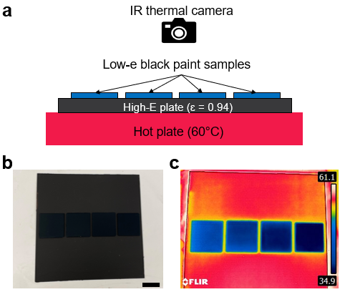
Figure S4. Visualized thermal effect of low-e black paints with different n-PBDF coating thicknesses. a) Schematic illustrating the experimental setup for taking the IR thermal images of low-e black paints using a thermal camera on a hot plate. The photo b) and the corresponding IR thermal image c) of low-e black paint samples. From left to right, the n-PBDF coating thicknesses for these four samples are 121 143, 168, and 194 nm, respectively. The scale bar in b) is 2 cm.

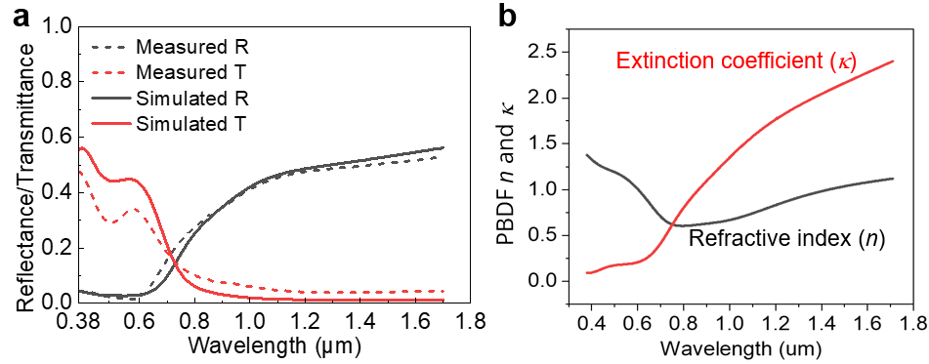
Figure S5. Spectra comparison for the n-PBDF coating layer. a) Measured and simulated spectra of a 168 nm thick n-PBDF particle coating layer coated on a 1 mm-thick glass slide. b) Refractive index and extinction coefficient of n-PBDF.

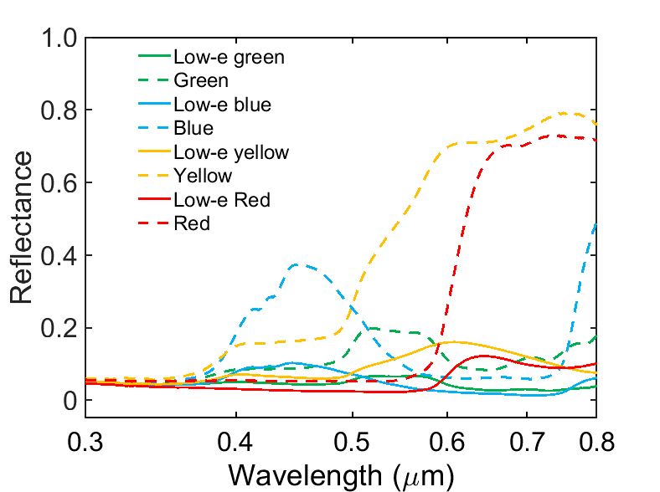
Figure S6. The reflectance spectra of commercial paints in green, blue, yellow, and blue and their corresponding low-e paints in the visible area from 0.3-0.8 µm.

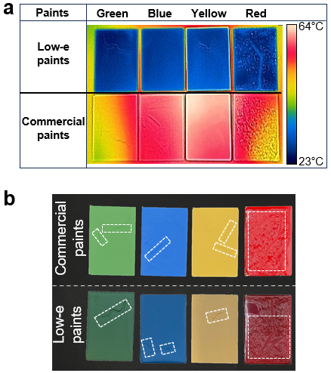
Figure S7. a) Infrared thermal image of colorful low-e paints (top row) and corresponding commercial paints (bottom row) in green, blue, yellow, and red (from left to right). b) Photographs showing the commercial-colored paints and the dual-layer low-e counterparts. The groove and wrinkle structures on both commercial paints and low-e paints are highlighted in dashed white rectangles. For both the infrared thermal images and photographs, the surface morphology of the samples is not entirely smooth, with grooves observed on the green, blue, and yellow paints (Sherwin-Williams) and a wrinkle-like structure present on the red paint (Rust-Oleum) samples. These features formed during the paint drying process. All paints were coated on 1 mm-thick glass slides in the dimension of 5×7.5 cm working as substrates. These samples were placed on a hot plate covered with a black metal plate, which has a surface emissivity of 0.94. The hot plate’s temperature was set to 60°C. After the temperature stabilized, the IR thermal image was captured using the thermal camera at room temperature. Under the thermal camera, low-e paints have a very low surface temperature because their surface emissivity is very low, demonstrating restricted thermal radiation. In contrast, due to the high emissivity of commercial paints, their surface temperatures are much higher.

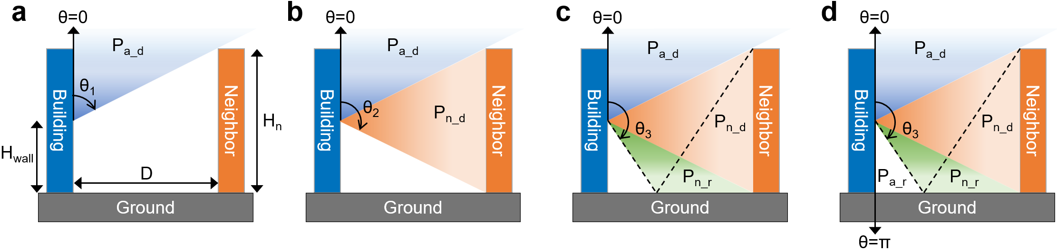
Figure S8. Radiative thermal absorption to the central point of the building wall with various zenith angles. a) $θ=0 to θ_{1}$: Thermal absorption from direct ambient emission; b) $θ=θ_{1} to θ_{2}$: Thermal emission from direct neighboring object emission; c) $θ=θ_{2} to θ_{3}$: Thermal absorption from reflected neighboring object emission; d) $θ=θ_{3} to π$: Thermal absorption from reflected ambient emission.

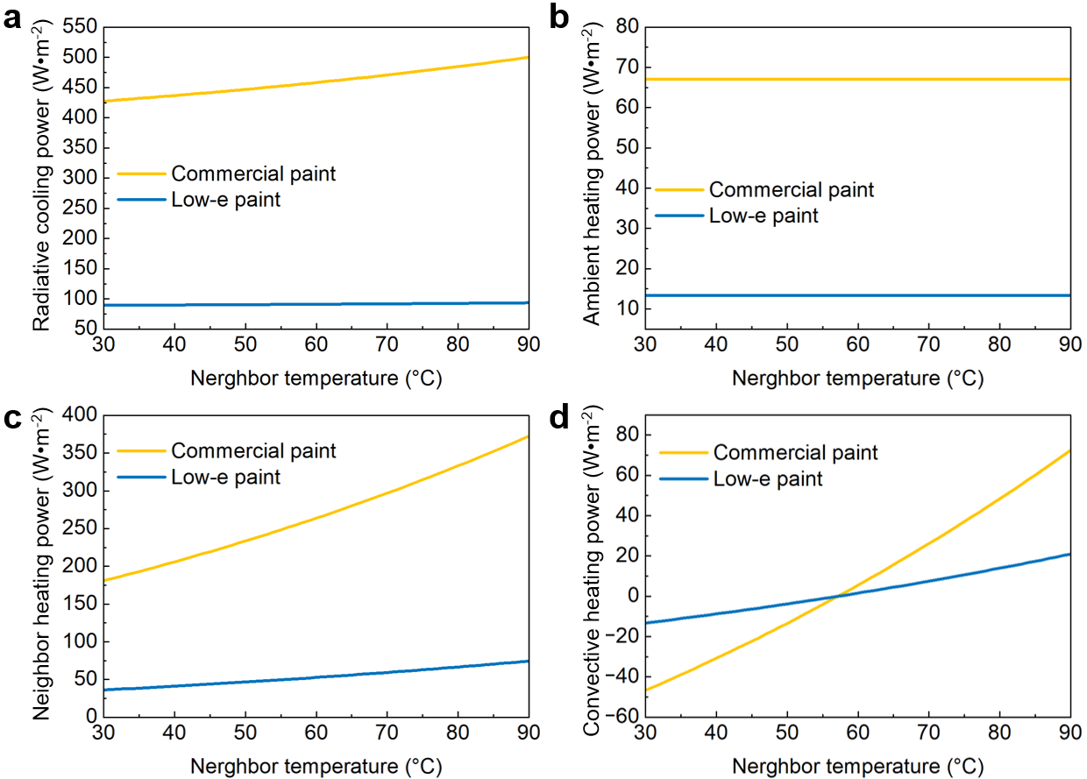
Figure S9. Simulated radiative power emitted to the outer space a), absorbed from ambient b), absorbed from neighboring objects c), and convective power exchanged with ambient d) for the studied building wall painted with commercial paint and low-e paint during hot climates.
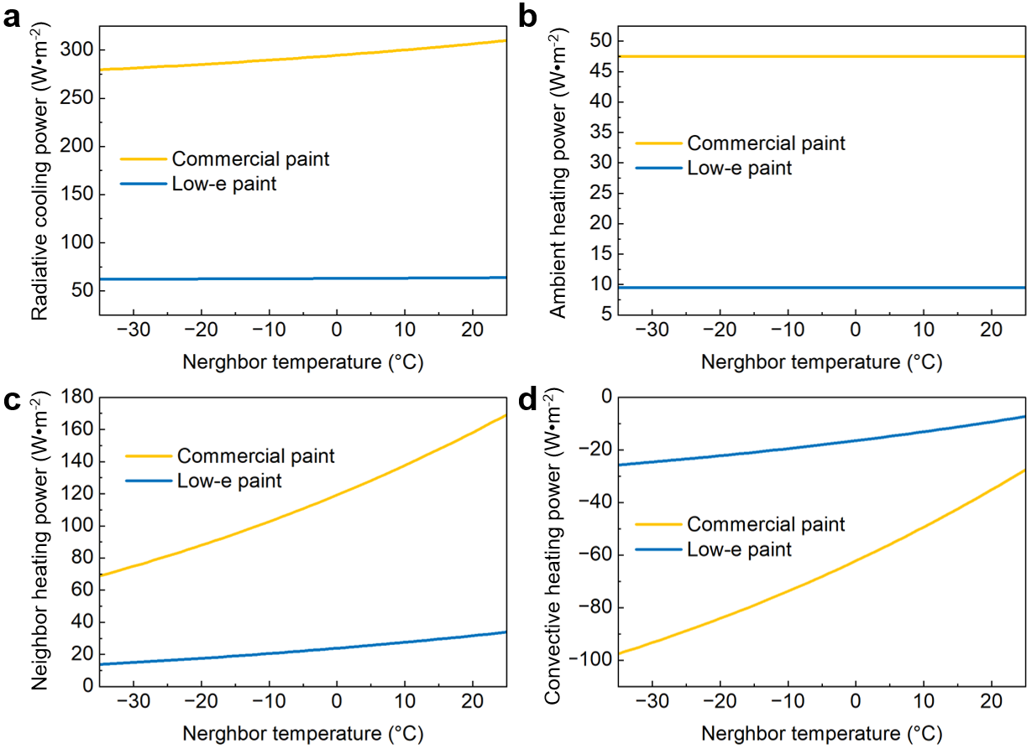
Figure S10. Simulated radiative power emitted to the outer space a), absorbed from ambient b), absorbed from neighboring object c), and convective power exchanged with ambient d) for the studied building wall painted with commercial paint and low-e paint during cold climate.

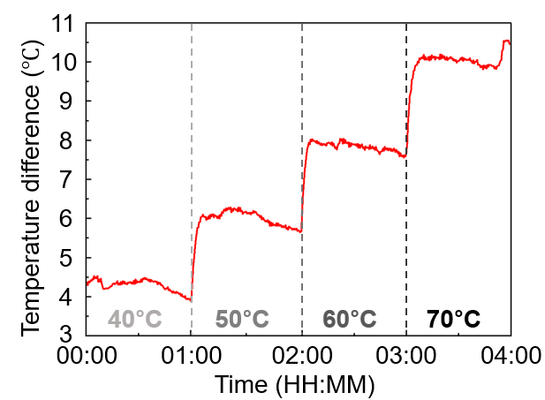
Figure S11. Temperature differences between commercial black paint and low-e black paint with the coating thickness of n-PBDF layer of 231 nm at various heating temperatures. The temperature values in the figure display the set temperature for the hot plates at each step with a time interval of 1 h.

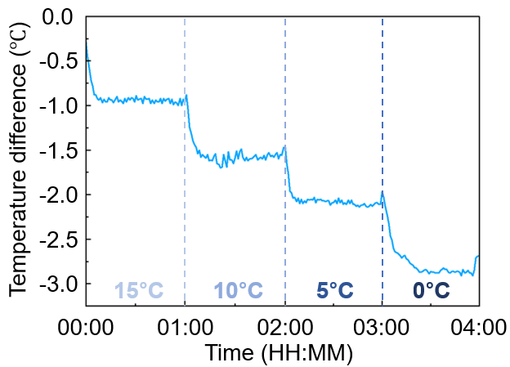
Figure S12. Temperature differences between commercial black paint and low-e black paint with the coating thickness of n-PBDF layer of 231 nm at various cooling temperatures. The temperature values in each figure display the set temperature for the cooling plates at each step with a time interval of 1 h.

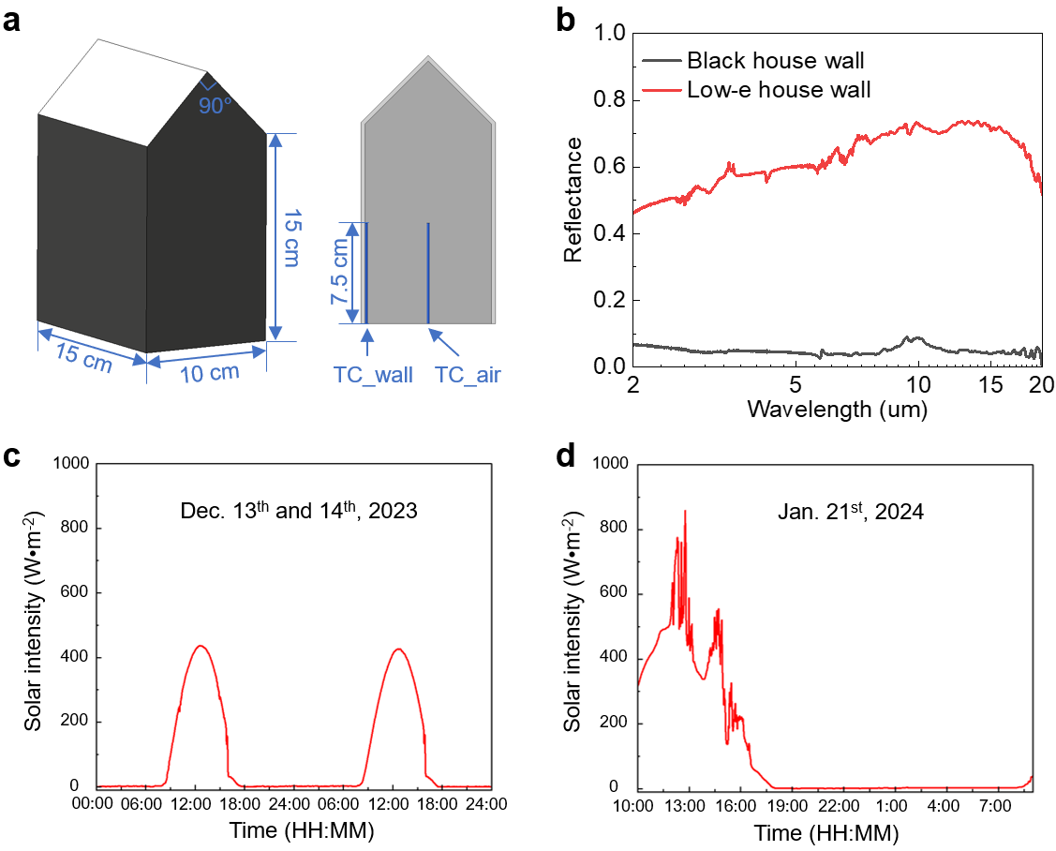
Figure S13. House model dimensions and ambient conditions for the field test. a) Schematically showing the dimensions of the hose used in the field test (left) and the fixed position of thermocouples in the house model (right). TC_wall is the thermocouple fixed at the center of the inner surface of the wall to measure the temperature of the wall. TC_air is the thermocouple fixed in the center of the house model space to measure the temperature of the inside air. b) Measured reflectance spectra of commercial black paint-coated wood board (black house wall) and low-e black paint-coated wood board (low-e house wall). Solar intensities for the field test on c) Dec. 13th and 14th, 2023, and on d) Jan. 21st, 2024.

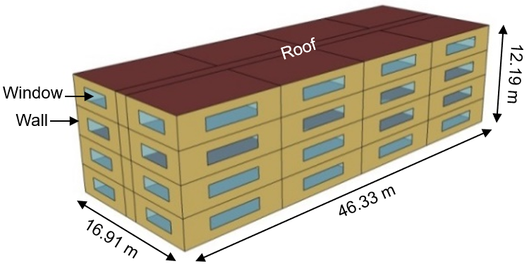
Figure S14. Midrise apartment model used in EnergyPlus for energy-saving evaluation of HVAC systems. For this apartment, the gross wall area is 7710.48 m² and the window opening area is 1146.45 m².

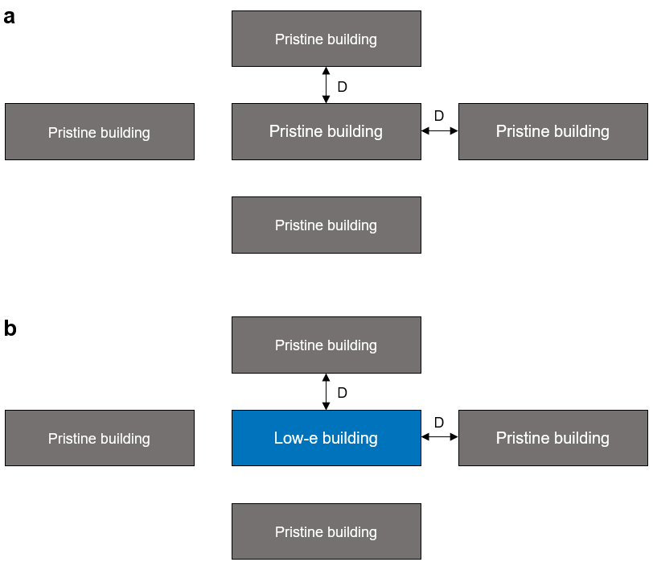
Figure S15. Schematic diagram of the building layout for the HVAC energy-saving simulation in EnergyPlus serving as a) baseline and b) experimental object. In the simulated model, the radiative energy from the surrounding buildings was considered. The studied building is surrounded by four buildings of the same size; that is, the four vertical walls of the studied building face a wall of the same size. All the surrounding buildings maintained the original parameters, aligned with conventional construction materials. a) shows the building layout for the baseline data in this simulation, where the central building is the original building. b) shows the layout of the experimental group data, where the central building is a low-e building with walls painted with low-e paint.

Table S1. Materials properties used in the energy-saving analysis of EnergyPlus
Materials | Thickness  (m) | Thermal conductivity  (W/ m K) | Density (kg/m³) | Specific heat  (J/kg K) | Thermal absorp. | Solar absorp. | Visible absorp.
Commercial black paint | 0.0008 | 0.2 | 3174 | 1500 | 0.9 | 0.78 | 0.78
Low-e black paint | 0.0008 | 0.2 | 3174 | 1500 | 0.9 | 0.78 | 0.78
Wood siding | 0.01 | 0.11 | 545 | 1210 | 0.9 | 0.78 | 0.78
Steel frame resident wall insulation | 0.07812 | 0.049 | 265 | 837 | 0.9 | 0.70 | 0.70
0.5-inch Gypsum board | 0.0127 | 0.16 | 785 | 830 | 0.9 | 0.92 | 0.92

References
[1] Z. Ke, A. Abtahi, J. Hwang, K. Chen, J. Chaudhary, I. Song, K. Perera, L. You, K. N. Baustert, K. R. Graham, J. Am. Chem. Soc. 2023, 145, 3706.
[2] Y. Tian, X. Liu, Z. Wang, J. Li, Y. Mu, S. Zhou, F. Chen, M. L. Minus, G. Xiao, Y. Zheng, Nano Energy 2022, 96, 107085.
[3] M. Bae, D. H. Kim, S.-K. Kim, Y. M. Song, Nanophotonics 2024.
[4] X. Li, J. Peoples, P. Yao, X. Ruan, ACS Appl. Mater. Interfaces 2021, 13, 21733.

